REPORT ON BATTERIES

LEAD-ACID BATTERY:-

*Lead-Acid battery is a type of secondary battery in which the electrical energy can be stored in the form of chemical energy and this chemical energy can be converted into electrical energy when required.*

*MATERIALS PRESENT IN LEAD-ACID BATTERY:-*

1. *Lead peroxide (PbO2).*
2. *Sponge lead (Pb)*
3. *Dilute sulfuric acid (H2SO4).*

*Lead Peroxide (PbO2):-*

*The positive plate is made of lead peroxide. This is dark brown, hard and brittle substance.*

*Sponge Lead (Pb):-*

*The negative plate is made of pure lead in soft sponge condition.*

*Dilute Sulfuric Acid (H2SO4):-*

*Dilute sulfuric acid used for lead acid battery has ration of water: acid = 3:1.*

* 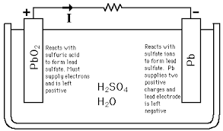*

*Positive plate is made up of Lead peroxide.*

*Negative plate is made up of sponge lead.*

*A Lead-Acid battery is formed by dipping the two plates into the sulphuric acid solution. When a load is connected, then molecules of acid split into hydrogen and sulphate ions.*

*The hydrogen ions react with +ve plate and the reaction follows as:-*

*PbO2 + 2H 🡪 PbO + H2O*

*PbO + H2SO4 🡪 PbSO4 + H2O*

*Total reaction:- PbO2 + H2SO4 + 2H 🡪 PbSO4 + 2H2O*

*The sulphate ions react with –ve plate and the reaction is:-*

*PbSO4 + 2H2 + SO4 🡪 PbO2 + 2H2SO4*

*Since, there is a flow of opposite charges to the plates, hence there is flow of current in the system. Charging of battery takes place when DC source is connected to plates and the inverse reaction takes place.*

*LITHIUM ION BATTERIES:-*

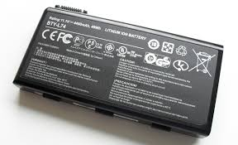

*A lithium-ion battery or Li-ion battery is a type of rechargeable battery in which lithium ions move from the negative electrode to the positive electrode during discharge and back when charging. Li-ion batteries use an intercalated lithium compound as one electrode material, compared to the metallic lithium used in a non-rechargeable lithium battery. The electrolyte, which allows for ionic movement, and the two electrodes are the constituent components of a lithium-ion battery cell.*

*Generally, the negative electrode of a conventional lithium-ion cell is made from carbon. The positive electrode is a metal oxide, and the electrolyte is a lithium salt in an organic solvent. The electrochemical roles of the electrodes reverse between anode and cathode, depending on the direction of current flow through the cell.*

*The most commonly used electrolyte is comprised of lithium salt, such as LiPF6 in an organic solution.*

*The positive electrode is made of Lithium cobalt oxide, or LiCoO2. The negative electrode is made of carbon. When the battery charges, ions of lithium move through the electrolyte from the positive electrode to the negative electrode and attach to the carbon. During discharge, the lithium ions move back to the LiCoO2 from the carbon.* *The movement of these lithium ions happens at a fairly high voltage, so each cell produces 3.7 volts.*

*LITHIUM POLYMER BATTERIES:-*

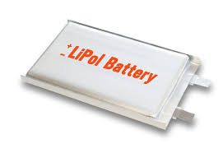

*Lithium-polymer batteries can be dated back to the 1970’s. Their first design included a dry solid polymer electrolyte that resembled a plastic film. Therefore, this type of battery can result in credit card thin designs while still holding relatively good battery life. In addition, lithium-polymer batteries are very lightweight and have improved safety. However, these batteries will cost more to manufacture and have a worse energy density than lithium-ion batteries.*

*A lithium polymer battery, or more correctly lithium-ion polymer battery, is a rechargeable battery of lithium-ion technology in a pouch format. Unlike cylindrical and prismatic cells, LiPos come in a soft package or pouch, which makes them lighter but also less rigid.*

*WORKING:-*

*Just as with other lithium-ion cells, LiPos work on the principle of intercalation and de-intercalation of lithium ions from a positive electrode material and a negative electrode material, with the liquid electrolyte providing a conductive medium. To prevent the electrodes from touching each other directly, a microporous separator is in between which allows only the ions and not the electrode particles to migrate from one side to the other.*

*{\displaystyle x\mathrm {LiC_{6}} \leftrightarrows x\mathrm {Li^{+}} +x\mathrm {e^{-}} +x\mathrm {C_{6}} }*